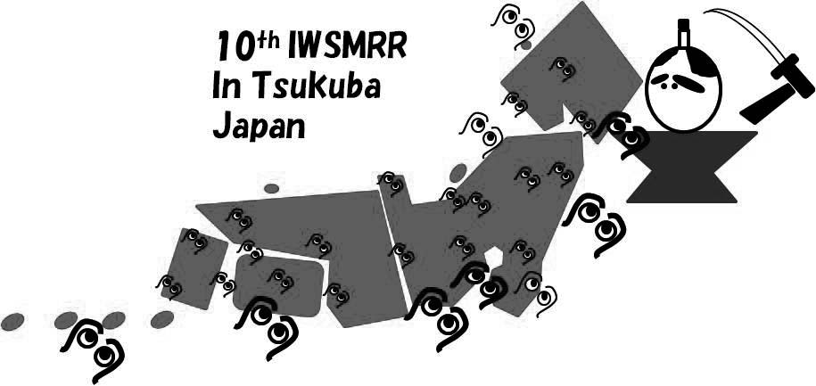
Abstract Title
10th International Workshop on Seismic Microzoning Risk Reduction
28 February-2 March, 2012
Tsukuba, Japan
Author A.B.(1), Other C.D.(2)
(1) Affiliation and Postal Address, email of first author
(2) Affiliation and Postal Address, email of second author
This is the space to introduce the text, graphs, tables and figures of your abstract. Please use lower case letters (Arial, 11pt, Justified).
Each one of the Abstracts should not exceed one A4 page.
Restrict to the use of greyscales only.

